**2022W-ľ2 BDM 2053 - Big Data Algoíithms and Statistic 01**

Lab 7

Submitted by: Ganesh Chaulagain (C0838561)

Tableau Report Generation

1. **Importing the Dataset:**

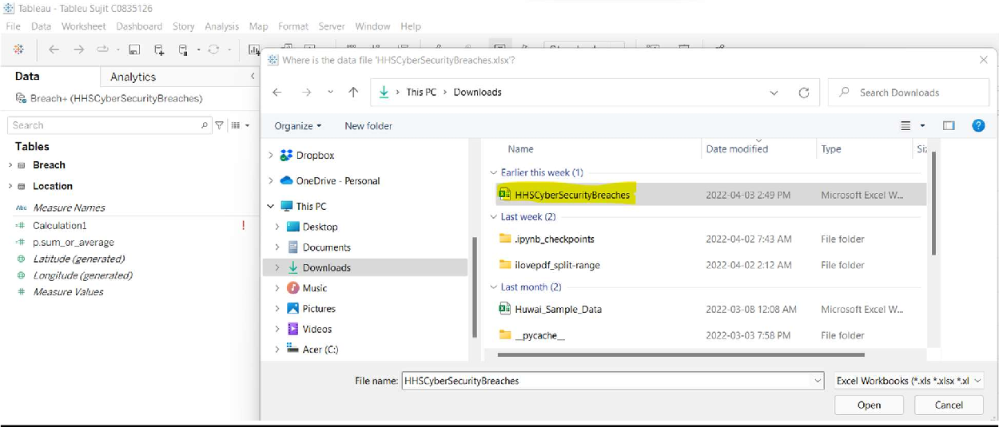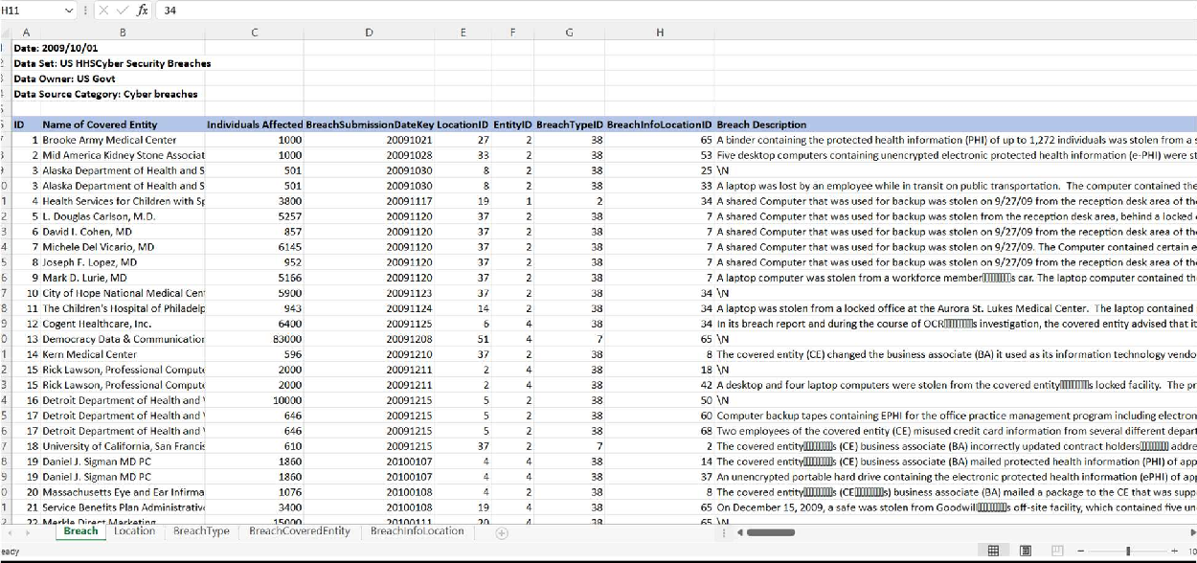

1. **Table Structure**

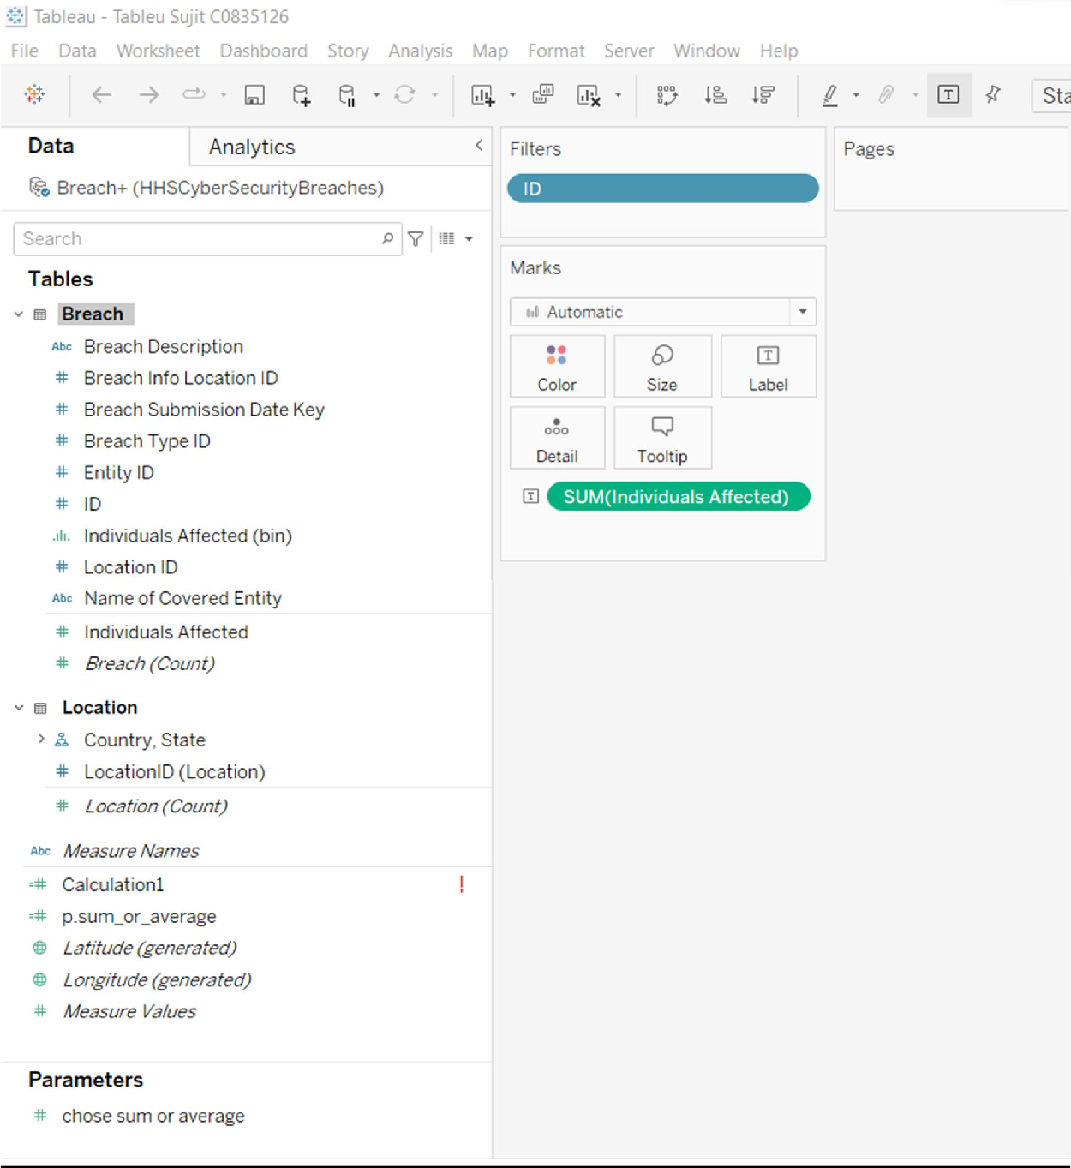

1. **Calculate avg, medians , minimum, maximum**

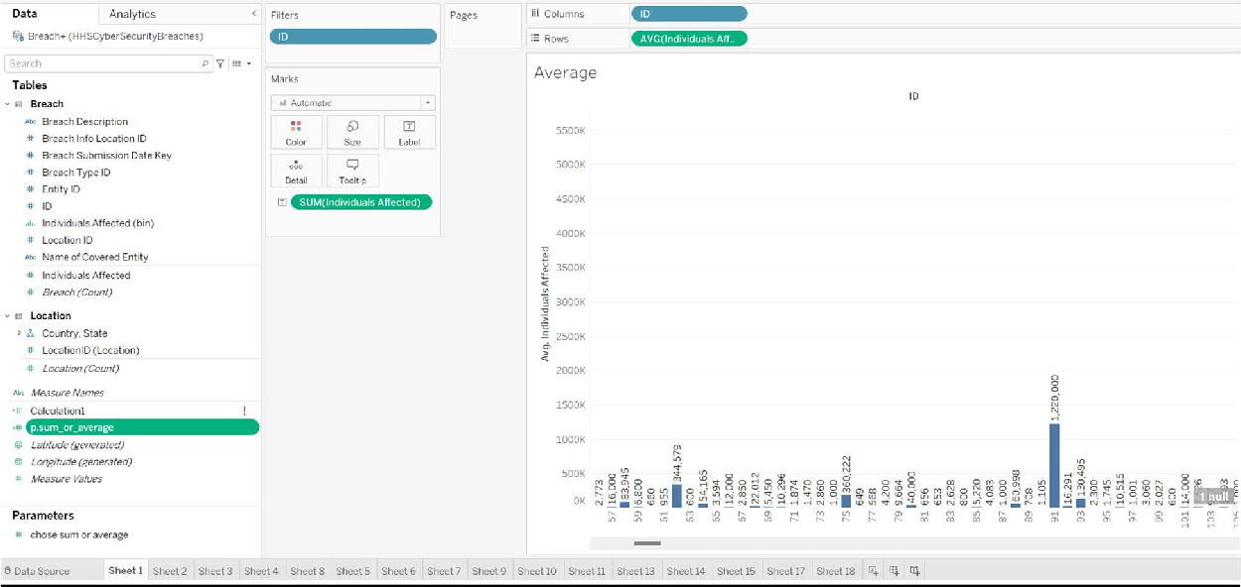

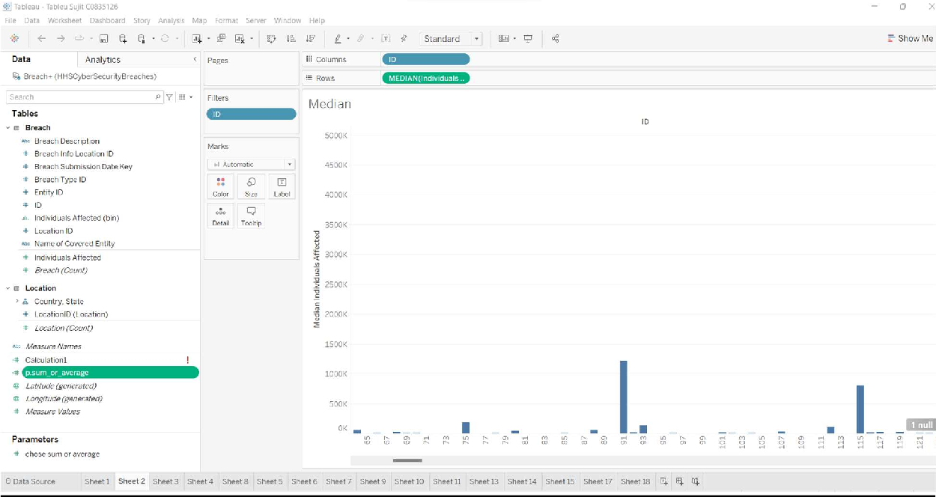

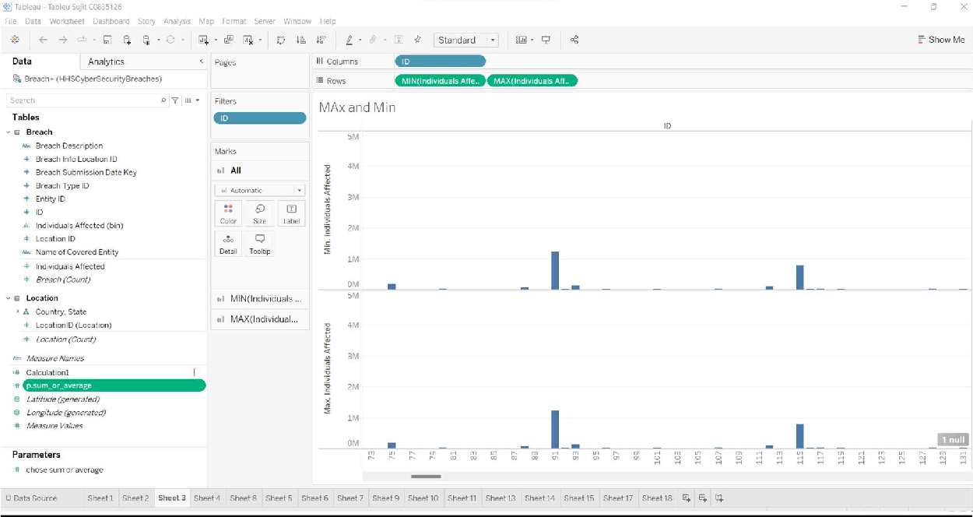

1. **Count**

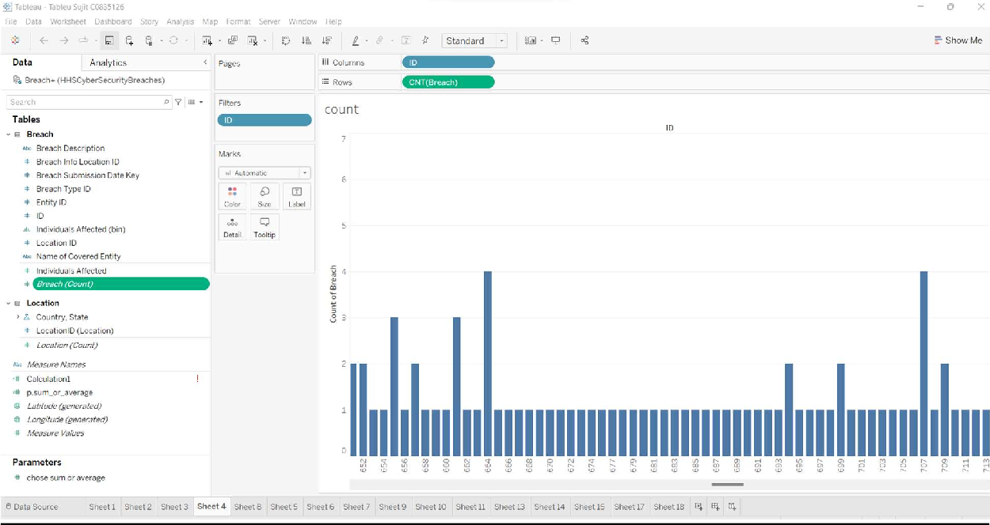

1. **Percentages within a table**

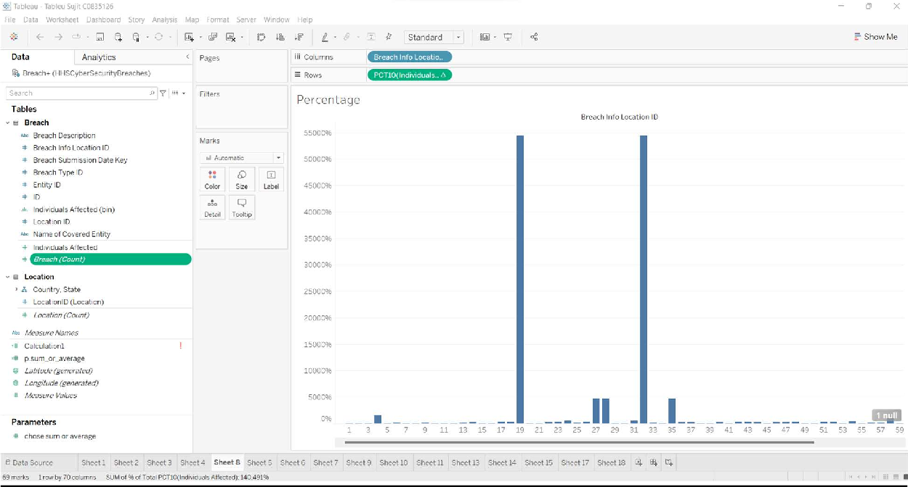

1. **Sort - Ascending , Descending**

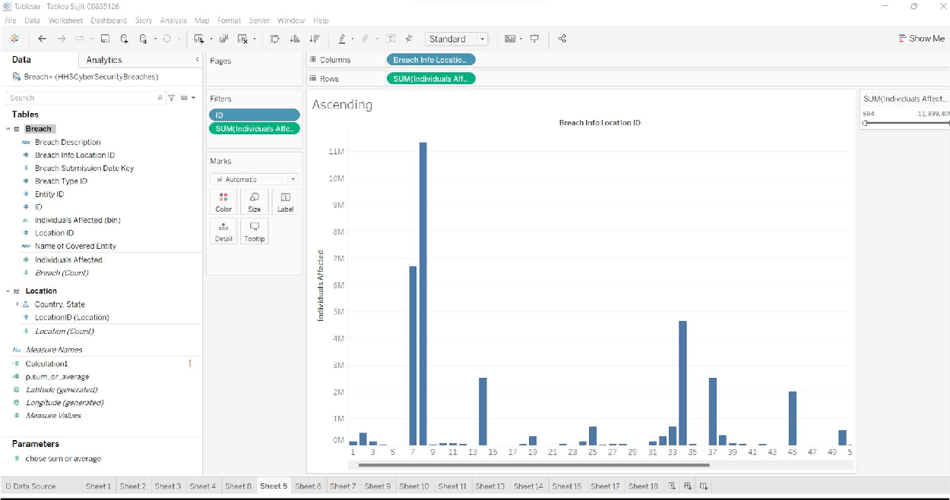

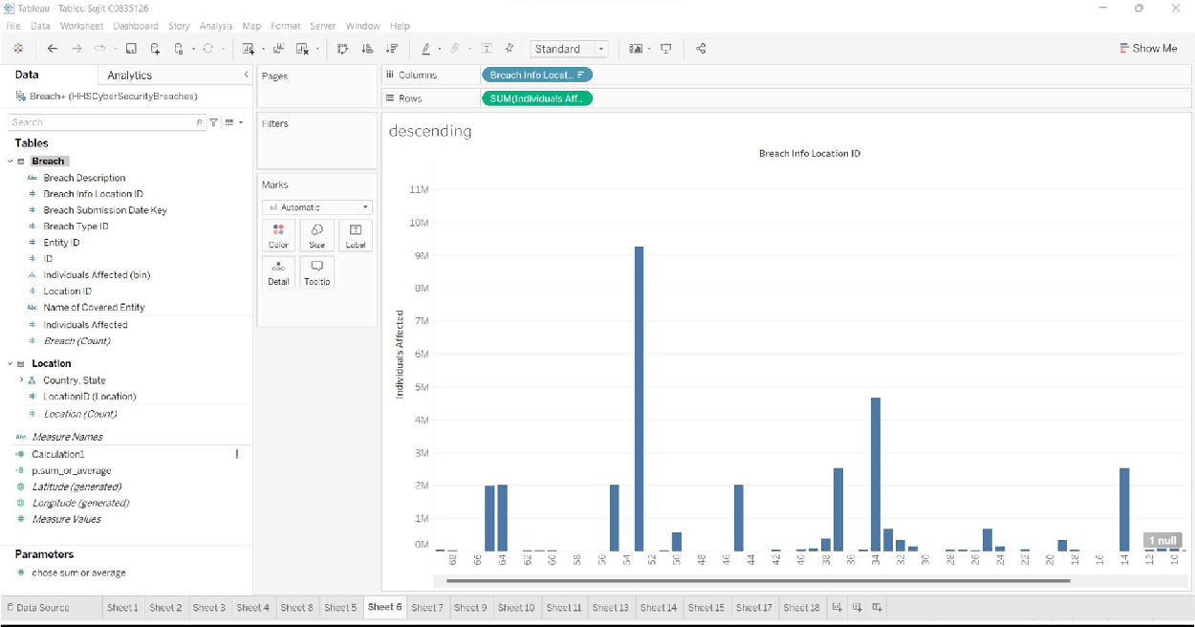

1. **Creating a selection filter/Applying filter**

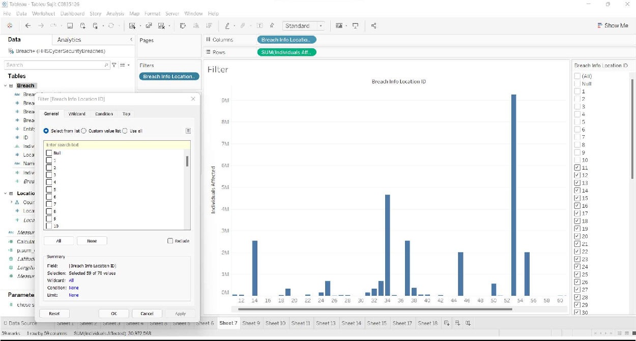

1. **Editing and Deleting parameters**

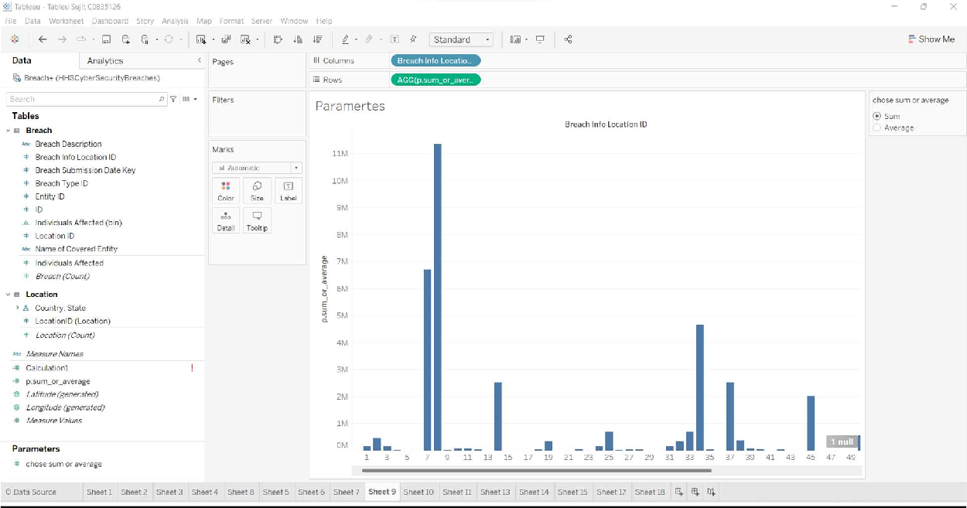

1. **Create Basic Visualizations**
2. **Column and stacked column charts**

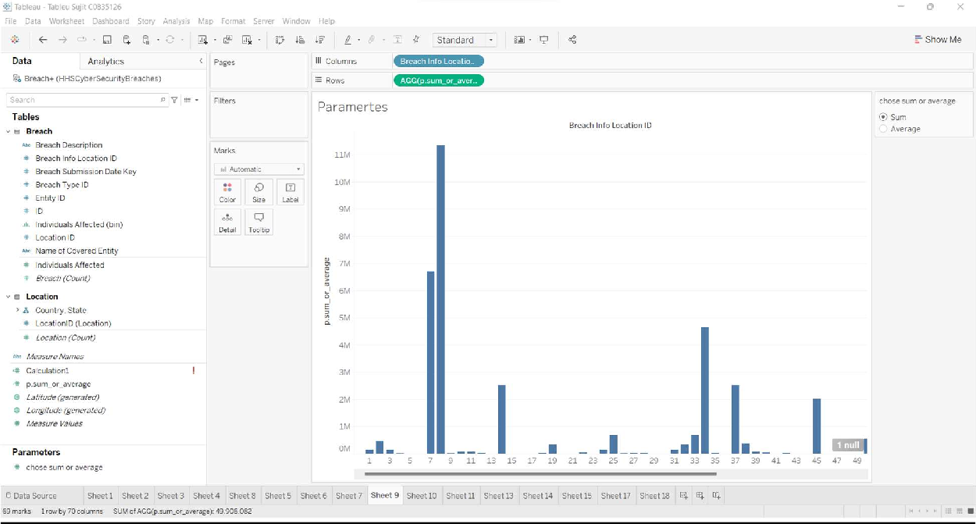

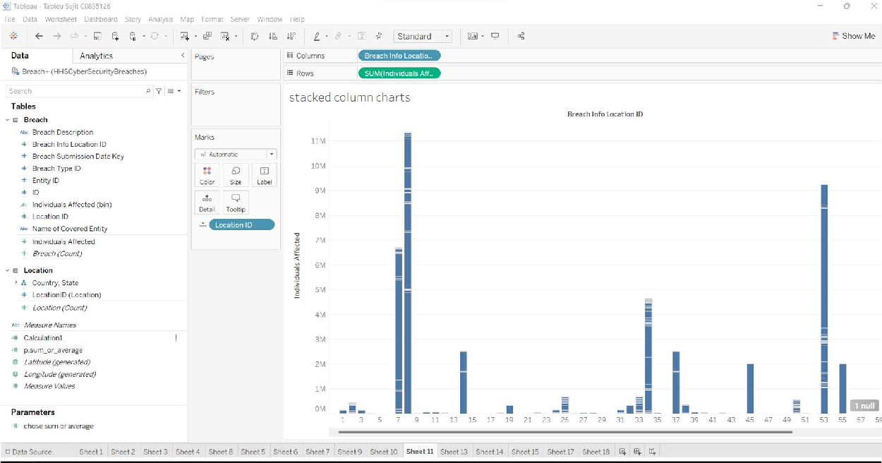

1. **Line Chart**

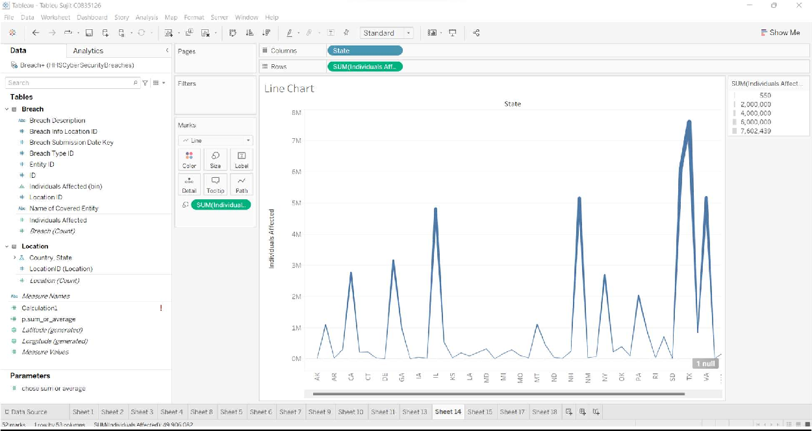

1. **Pie Chart**

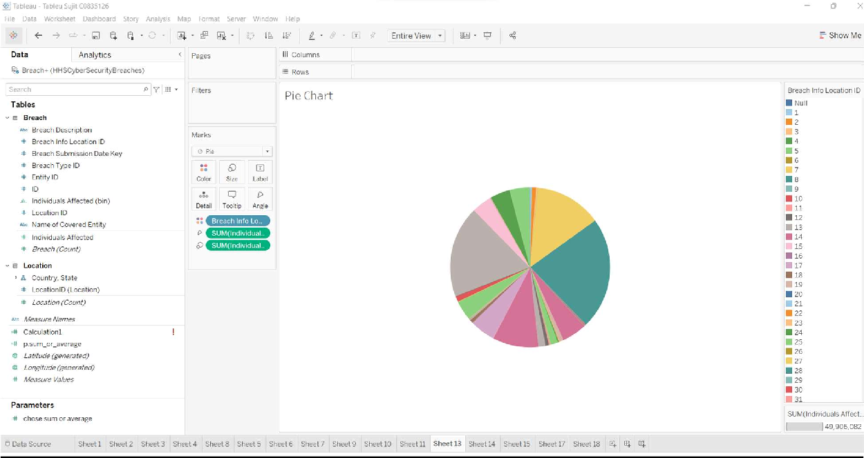

1. **Scatter Chart**

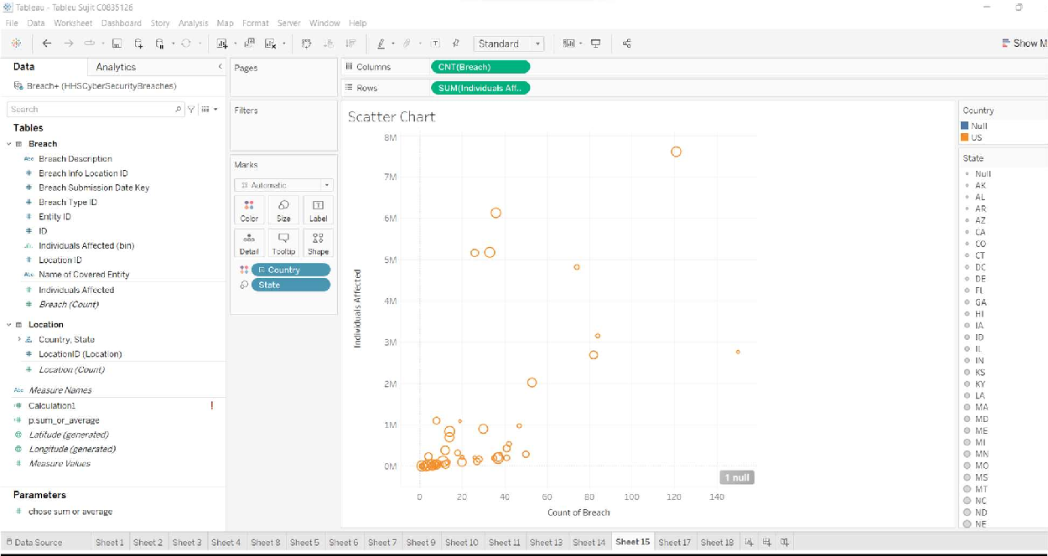

1. **Data Cluster**

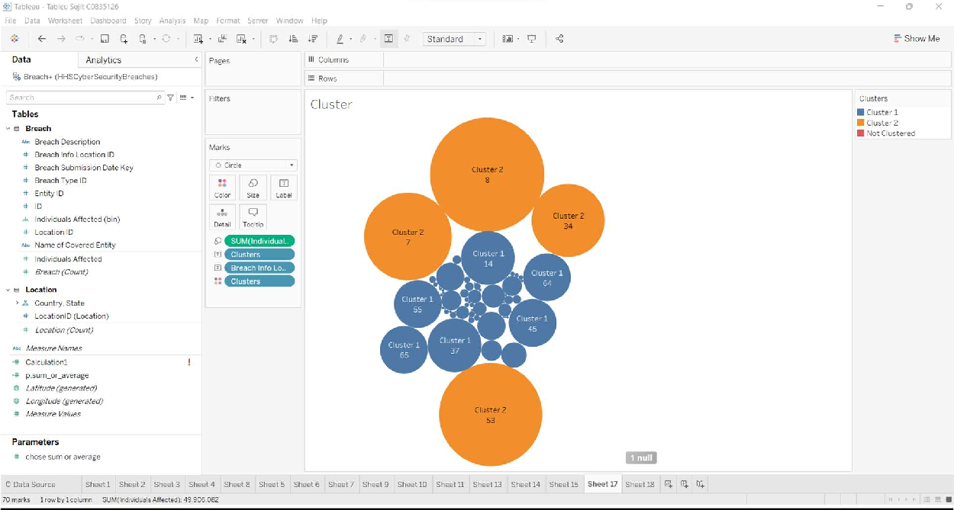

1. **Tree Map**

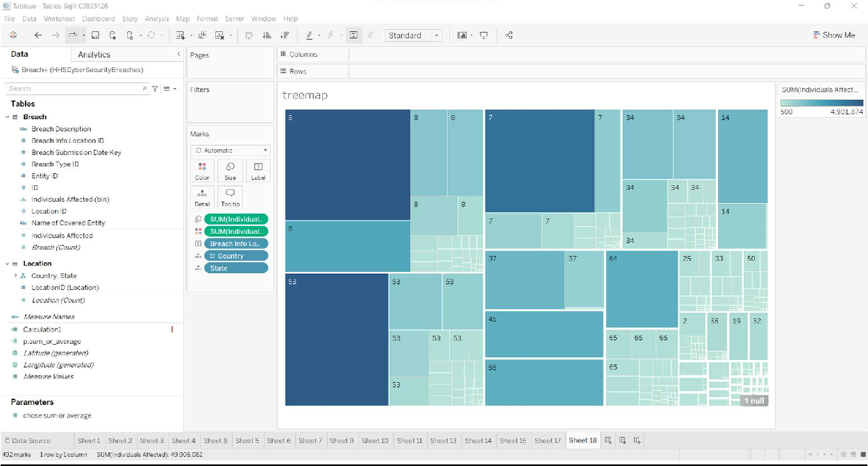

1. **Dashboard**

